New Business June 25, 2012

- Approval of Literacy Plan
New Prague Area Schools Literacy Plan
2011-2012



“Literacy is the ability to read, write, speak, listen, view, visually represent,
and think in order to communicate and contribute to society.”
~International Reading Association

OVERVIEW OF LOCAL LITERACY PLAN REQUIREMENTS
The New Prague Area School District is committed to ensuring that all students can read at or above grade level by the end of third grade.
- Statement of Goals and Objectives

Our literacy goals:

- Our high-stakes testing ensures that all teachers know and understand the importance of providing a high quality literacy program that is rigorous and relevant and providing the appropriate differentiation/research based interventions when needed to ensure student success. The two main resources used include SUPERKIDS by Rowland Reading Foundation and Reading Streets by Scott Foresman.

- All staff will participate in planned, job-embedded, data-driven professional development to ensure best-practice instruction is aligned with the Minnesota Academic Standards and delivered to our students.

- Every child in our Kindergarten through third grade will receive between 90 to 120 minutes of reading instruction a day.

- Formative and summative assessments (normed, screening, diagnostic) will be used to identify and match students to research-based interventions.

- Assessment information will be shared with teachers/parents/guardians. Throughout the year, feedback in the form of progress monitoring will inform and assist learning at school and at home.

Our Literacy Data

The New Prague Area School District will use the NWEA MAP K-3, DIBELS, and MCA, assessments to establish baseline data for each child and to identify students who are in need of reading intervention services.

The elementary schools in our district track students reading achievement using NWEA MAP K-3 and the Fountas & Pinnell (F&P) Benchmark Assessment System.

Count of Students ‘at or above grade level’ and Count of Students Assessed

 |  | District Summary |  |  | Eagle View Elementary |  |  | Raven Stream Elementary |  |  | Falcon Ridge Elementary
 |  |  | Number |  |  | Number |  |  | Number |  |  | Number
Grade | Measure | % | Number of students at or above grade level | Number Students Assessed | % | Number of students at or above grade level | Number Students Assessed | % | Number of students at or above grade level | Number Students Assessed | % | Number of students at or above grade level | Number Students Assessed
Kindergarten | Letter Naming Fluency |  |  |  | 88 | 73 | 83 | 78 | 85 | 109
Kindergarten | Phoneme Seg. Fluency | 87.3 | 261 | 299 | 88 | 73 | 83 | 84.4 | 92 | 109 | 89.7 | 96 | 107
Kindergarten | Nonsense Word Fluency | 76.6 | 229 | 299 | 90.4 | 75 | 83 | 67.9 | 74 | 109 | 74.8 | 80 | 107
Grade 1 | Oral Reading Fluency | 77.2 | 220 | 285 | 78.5 | 73 | 93 | 73.1 | 76 | 104 | 80.7 | 71 | 88
Grade 2 | Oral Reading Fluency | 77.2 | 227 | 294 | 85.2 | 75 | 88 | 73.1 | 76 | 104 | 74.5 | 76 | 102
Grade 3 | Oral Reading Fluency | 76.1 | 217 | 285 | 82.1 | 64 | 78 | 67 | 71 | 106 | 81.2 | 82 | 101

- Statement of Process to Assess Students
Process to assess students’ level of reading proficiency:

The following chart describes the New Prague Timeline for the delivery of each reading/literacy assessment and how proficiency is determined.

Grade | Name of Test or Assessment | Test Dates | Grade Level Expectations
Kindergarten | MAP – Math, Reading (Fall, Winter, Spring) | September 12th – September 30th | R-142.5 M-143.7 Norm Target
 |  | January 3rd – January 18th | R-151 M-150.7 Norm Target
 |  | April 23rd – May 25th | R-157.7 M-159.1 Norm Target
 | DIBELS-Composite Scores—FSF; PSF; NWF | Fall | 26-170
 |  | Winter (Composite Score) | 122-394
 |  | Spring (Composite Score) | 119-334
First Grade | MAP – Math, Reading (Fall, Winter, Spring) | September 12th – September 30th | R-160.3 M-162.8 Norm Target
 |  | January 3rd – January 18th | R-170.7 M-172.4 Norm Target
 |  | April 23rd – May 25th | R-176.9 M-179 Norm Target
 | DIBELS | Fall—PSF and NWF | PSF-40+ NWF-27+: 1
 |  | Winter—NWF and ORF | NWF-43+: 8+ /ORF-23+
 |  | Spring—NWF and ORF | NWF-58+: 13+/ ORF-47+
Second Grade | MAP – Math, Reading (Fall, Winter, Spring) | September 12th – September 30th | R-175.9 M-178.2 Norm Target
 |  | January 3rd – January 18th | R-183.6 M-185.5 Norm Target
 |  | April 23rd – May 25th | R-189.6 M-191.3 Norm Target
 | DIBELS | Fall—NWF and ORF | NWF-54+/ORF-52+
 |  | Winter –ORF | ORF-72+
 |  | Spring—ORF | ORF-87+
 | CoGat7 | February 8th – February 9th | 95%-100% Gifted and Talented

Grade | Name of Test or Assessment | Test Dates | Grade Level Expectations
Third Grade | MAP – Math, Reading (Fall, Winter, Spring) | September 12th – September 30th | R-189.9 M-192.1 Norm Target
 |  | January 3rd – January 18th | R-194.6 M-198.5 Norm Target
 |  | April 23rd – May 25th | R-199.2 M -203.1 Norm Target
 | DIBELS | Fall–ORF | 70+
 |  | Winter–ORF | 86+
 |  | Spring–ORF | 100+
 | MCA II Reading | April 18th – April 19th | 350 Meets Proficiency Score
 | MCA III Mathematics (Online) | March 6th-March 16th | 350 Meets Proficiency Score
 |  | April 10th-April 24th | 350 Meets Proficiency Score
 |  | May 1st-9th | 350 Meets Proficiency Score
Fourth Grade | MAP – Math, Reading (Fall, Winter, Spring) | September 12th – September 30th | R-199.8 M-203.8 Norm Target
 |  | January 3rd – January 18th | R-203.2 M-208.7 Norm Target
 |  | April 23rd – May 25th | R-206.7 M -212.5 Norm Target
 | DIBELS | Fall–ORF | 90+
 |  | Winter–ORF | 103+
 |  | Spring–ORF | 115+
 | MCA II Reading | April 18th – April 19th | 450 Meets Proficiency Score
 | MCA III Mathematics (Online) |  | 450 Meets Proficiency Score
 | CoGat7 | February 8th – February 9th | 95%-100% Gifted and Talented
Fifth Grade | MAP – Math, Reading (Fall, Winter, Spring) | September 12th – September 30th | R-207.1 M -212.9 Norm Target
 |  | January 3rd – January 18th | R-209.8 M -217.8 Norm Target
 |  | April 23rd – May 25th | R-212.3 M- 221 Norm Target
 | DIBELS | Fall–ORF | 111+
 |  | Winter–ORF | 120+
 |  | Spring–ORF | 130+
 | MCA II Reading | April 18th – April 19th | 550 Meets Proficiency Score
 | MCA III Mathematics (Online) |  | 550 Meets Proficiency Score
 | MCA II Science (Online) | April 25th – April 26th | 550 Meets Proficiency Score

Grade | Name of Test or Assessment | Test Dates | Grade Level Expectations
Sixth Grade |  | September 12th – September 30th | R-212.3 M -219.6 Norm Target
 | MAP – Math, Reading (Fall, Winter, Spring) | January 3rd – January 18th | R-214.3 M -222.8 Norm Target
 |  | April 23rd – May 25th | R-216.4 M-225.6 Norm Target
 | MCA II Reading | April 18th – April 19th | 650 Meets Proficiency Score
 | MCA III Mathematics (Online) |  | 650 Meets Proficiency Score
Seventh Grade |  | September 12th – September 30th | R-216.3 M-225.6 Norm Target
 | MAP – Math, Reading (Fall, Winter, Spring) | January 3rd – January 18th | R-218.2 M-228.2 Norm Target
 |  | April 23rd – May 25th | R-219.7 M-230.5 Norm Target
 | MCA II Reading | April 18th – April 19th | 750 Meets Proficiency Score
 | MCA III Mathematics (Online) |  | 750 Meets Proficiency Score
Eighth Grade |  | September 12th – September 30th | R-219.3 M-230.2 Norm Target
 | MAP – Math, Reading (Fall, Winter, Spring) | January 3rd – January 18th | R-221.2 M-232.8 Norm Target
 |  | April 23rd – May 25th | R-222.4 M-234.5 Norm Target
 | MCA II Reading | April 18th – April 19th | 850 Meets Proficiency Score
 | MCA III Mathematics (Online) |  | 850 Meets Proficiency Score
 | MCA II Science (Online) | May 15th –May 16th

Grade | Name of Test or Assessment | Test Dates | Grade Level Expectations
Ninth Grade | MAP – Math, Reading (Fall) | September 12th – September 30th | R-221.4 M-233.8 Norm Target
 | MCA – GRAD Written Composition | November 2nd
Tenth Grade | MCA II Reading/GRAD | April 17th – April 18th | 1050 Meets Proficiency Score
 | MCA – GRAD Written Composition Retest | November 2nd
 | MCA II Science (Online) | May 15th –May 16th
Eleventh Grade | MCA II Mathematics | April 17th-April 18th | 1150 Meets Proficiency Score
 | MCA – GRAD Written Composition Retest | November 2nd
 | MCA II Reading GRAD Retest | Aug. 3rd, Oct. 4th, Dec. 6th, Feb. 7th, Apr. 9th, June 8th
Twelfth Grade | MCA II Reading GRAD Retest | Aug. 3rd, Oct. 4th, Dec. 6th, Feb. 7th, Apr. 9th, June 8th
 | MCA II Mathematics GRAD Retest | Aug. 2nd, Oct. 5th, Dec. 7th, Feb. 8th, Apr.10th, June 8th
 | MCA – GRAD Written Composition Retest | November 2nd , April 24th
Grades K-12 | ACCESS | March 7th – March 25th
Grades K-12 | MTAS | March 28th – April 29th
MCA – Minnesota Comprehensive Assessment
- MCA Reading and Mathematics – Grades 3-8
- MCA Reading – Grade 10
- MCA Mathematics – Grade 11
- MCA Science – Grades 5, 8, and 10
- MCA GRAD Written Composition – Grade 9
COGAT7
- Ability Test – Grade 2
- Ability Test – Grade 4
ACCESS
- LEP-identified students

MTAS
- Alternate Assessment in Reading and Mathematics for Special Education

NWEA MAP- Measure of Academic Progress
- Mathematics and Reading – Grade 2-9
- Primary Map – Grades K-1

GRAD – Graduation Required Assessment for Diploma
- GRAD Reading – Grade 10
- GRAD Mathematics – Grade 11
- Written Composition Retest – Grades 10, 11, & 12

The New Prague Area School District will notify and involve parents in the literacy development of their child in the following ways:

If a child is in need of an intervention in our district the following steps of communication will occur:

Parent Notification for Response to Intervention
Step 1---Throughout the school year, discussion with the parents and communication of a researched-based intervention plan will be conducted. The conversation will revolve around the needed partnership roles of the school and roles of the parents to ensure student growth in literacy. This can be done by the following means:
  - Phone call
  - Parent teacher conferences
  - Individual meeting

Step 2---Send home the follow-up information:
- Parent Notification Letter requiring a parent/guardian signature. After a personal conversation between parent and teacher, parents will be asked to sign a permission slip.
- Building Intervention information and helpful literacy tips. Parents will be provided literacy learning opportunities throughout the year to support literacy learning at home.
Step 3 –Follow-up discussion and progress monitoring updates provided as needed
- Parents are encouraged to contact their child’s classroom teacher for regular progress monitoring updates.

Community stakeholder groups, i.e., peer assistants, senior readers, parent volunteers, and a variety of community volunteers will engage in literacy opportunities.

Included in this document is a copy of New Prague Elementary Schools’ Entrance/Exit Process for Support Services in Reading
Draft Compiled by the RTI /Teaching and Learning Team: January 22, 2010

School-wide benchmarking takes place 3 times per school year: fall, winter, and spring. In the beginning weeks of the school year, previous year’s spring data as well as recent MCA scores for grades 4-5 is used to determine immediate support before fall benchmarking. Collaboration meetings will take place at each grade level.
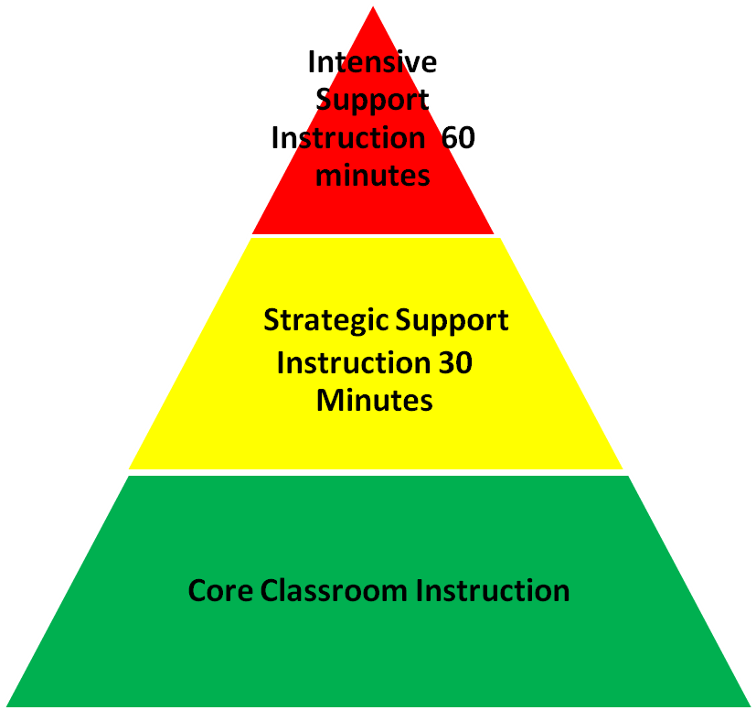
Students’ results will be used to place each child in
one or more of the following RTI Tiers:

Three Green: Receive Core Classroom Instruction
Two Green/ One Yellow: Core Classroom Instruction- Teacher Monitor
One Green/Two Yellow: Strategic Instruction- 30 minutes of Support
One Green/One Yellow/ One Red: Strategic Instruction-30minutes of Support
Two Yellow/One Red: Strategic Instruction-30minutes of Support
One Yellow/Two Red: Intensive Support- 60 minutes of Support
Three Red: Intensive Support

Entry Guidelines: Triangulate the Data from Fall Assessments
**Kindergarten Data is used as a baseline for future assessment comparisons

Fall Assessments: Beginning Second Week of School (September)

Kindergarten | First Grade | Second Grade | Third Grade | Fourth Grade | Fifth Grade
DIBELS  *Initial Sound Fluency  *Letter Naming Fluency | DIBELS  *Letter Naming Fluency  *Phoneme Segmentation Fluency  *Nonsense Word Fluency | DIBELS  *Nonsense Word Fluency  *Oral Reading Fluency | DIBELS  *Oral Reading Fluency | DIBELS  *Oral Reading Fluency | DIBELS  *Oral Reading Fluency
NWEA  Primary Reading Survey w/goals | NWEA  Primary Reading Survey w/goals | NWEA  Reading Survey w/ Goals 2-5 | NWEA  Reading Survey w/ Goals 2-5 | NWEA  Reading Survey w/ Goals 2-5 | NWEA  Reading Survey w/ Goals 2-5
 | F&P  (Diagnostic Reading Assessment) | F&P  (Diagnostic Reading Assessment) | F&P  (Diagnostic Reading Assessment) | F&P  (Diagnostic Reading Assessment) | F&P  (Diagnostic Reading Assessment)
 |  |  |  | MCA II  Minnesota Comprehensive Assessment | MCA II  Minnesota Comprehensive Assessment)

Entry Guidelines: Triangulate the Data from Winter Assessments
**Kindergarten Data is used as a baseline for future assessment comparisons

Winter Assessments: First Week in January
Entry/Exit Guidelines: Triangulate the Data from Winter Assessments

Kindergarten | First Grade | Second Grade | Third Grade | Fourth Grade | Fifth Grade
DIBELS  *Initial Sound Fluency  *Letter Naming Fluency  *Phoneme Segmentation Fluency  *Nonsense Word Fluency | DIBELS  *Phoneme Segmentation Fluency  *Nonsense Word Fluency  *Oral Reading Fluency | DIBELS  *Oral Reading Fluency | DIBELS  *Oral Reading Fluency | DIBELS  *Oral Reading Fluency | DIBELS  *Oral Reading Fluency
**Administered in December | F&P  (Diagnostic Reading Assessment) | F&P  (Diagnostic Reading Assessment) | F&P  (Diagnostic Reading Assessment) | F&P  (Diagnostic Reading Assessment) | F&P  (Diagnostic Reading Assessment)
 | Fry Sight Words  First 100 | NWEA Survey- Reading  *Used for consideration of exiting/entering | NWEA Survey- Reading  *Used for consideration of exiting/entering | NWEA Survey- Reading  *Used for consideration of exiting/entering | NWEA Survey- Reading  *Used for consideration of exiting/entering
 |  | Fry Sight Words  Second 100 | DAZE | DAZE | DAZE

Entry Guidelines: Triangulate the Data from Spring Assessments
**Kindergarten Data is used as a baseline for future assessment comparisons

Spring Assessments: April/May

Kindergarten | First Grade | Second Grade | Third Grade | Fourth Grade | Fifth Grade
DIBELS  *Letter Naming Fluency  *Phoneme Segmentation Fluency  *Nonsense Word Fluency | DIBELS  *Phoneme Segmentation Fluency  *Nonsense Word Fluency  *Oral Reading Fluency | DIBELS  *Oral Reading Fluency | DIBELS  *Oral Reading Fluency | DIBELS  *Oral Reading Fluency | DIBELS  *Oral Reading Fluency
NWEA  Primary Reading Survey w/goals | NWEA  Primary Reading Survey w/goals | NWEA  Reading Survey w/ Goals 2-5 | NWEA  Reading Survey w/ Goals 2-5 | NWEA  Reading Survey w/ Goals 2-5 | NWEA  Reading Survey w/ Goals 2-5
F&P  (Diagnostic Reading Assessment) | F&P  (Diagnostic Reading Assessment) | F&P  (Diagnostic Reading Assessment) | F&P  (Diagnostic Reading Assessment) | F&P  (Diagnostic Reading Assessment) | F&P  (Diagnostic Reading Assessment)
Kindergarten Assessment | Fry Sight Words  First 100 | Fry Sight Words  Second 100 | Fry Sight Words  Third 100 | DAZE | DAZE

Literacy Resources for Parents

Listed below are resources and tools for parents, caregivers, and/or community members to support literacy practices at home.

Reading Rockets | http://www.readingrockets.org/audience/
International Reading Association (IRA) | http://www.reading.org/informationfor/parents.aspx
MN MDE Lifelong Literacy | http://education.state.mn.us/MDE/StuSuc/LifelongLiteracy/index.html
Early Literacy Resources | http://www.duluth.lib.mn.us/programs/BookTime/Resources.html
FCRR | http://www.fcrr.org/curriculum/curriculumForParents.shtm
Books All Around | http://www.booksallaround.org/

- Intervention and Instructional Supports
Core Instruction: Our core instruction is aligned to the 2010 ELA Academic Standards and specifically addresses the development of the components of reading that are consistent with section 122A.06, subdivision 4. The curriculum is SUPERKIDS by Rowland Reading Foundation and Scott Foreman’s Reading Streets, 2008 with an aligned intervention resource, My Sidewalks. These programs provide the needed structure for meeting the Common Core Standards.

During the 90- 120 minutes allocated to literacy, classrooms provide a supportive framework (Modeled Reading, Shared Reading, Interactive Reading, Guided Reading, and Self-Selected Independent Reading) for learning gradually releasing the responsibility from teacher to student.

Student needs are addressed with differentiated instruction. Principals, teachers, and intervention specialists work together to promote the proficient use of literacy practices and instructional strategies. Additional time and support is built into the day to provide small-group and/or one-on-one interventions linked to core instruction through the coordinated efforts of Title 1, RTI tier I, II, and III interventions, MN Reading Corps (MRC), English Learners program (EL), and Special Education.
Progress monitoring checks are conducted by the classroom teachers and the intervention specialists to ensure that the interventions are effective for the students most in need of additional support.

New Prague Area Schools Elementary Reading
Pyramid of Interventions
2011-2012

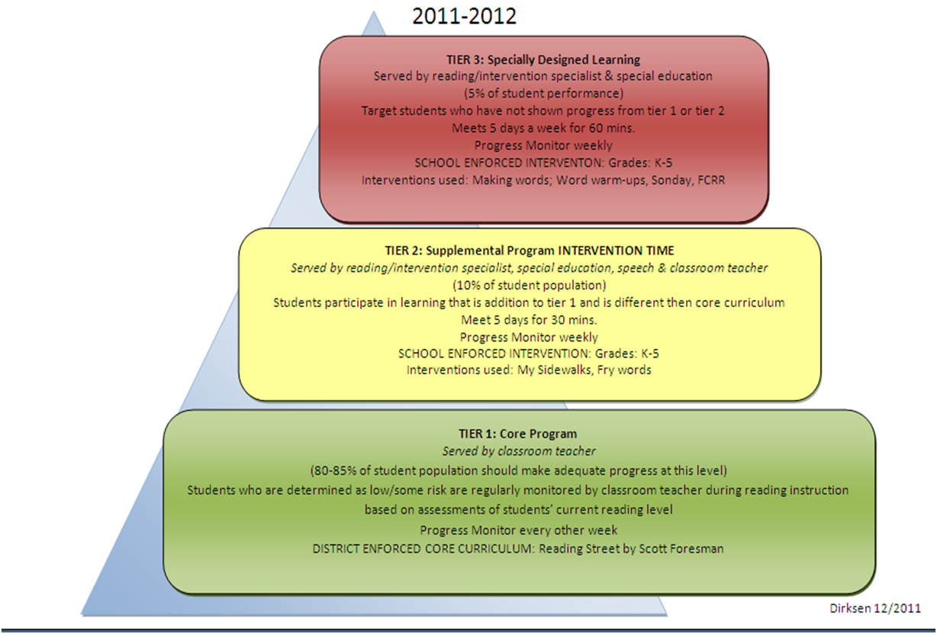

Below is a chart of our district-wide reading interventions. If your child has been identified as needing services, the interventions listed below may be used to strengthen those areas of concern. The selected intervention will be determined by the data collected from our NWEA, DIBELS, and MCA results.

As previously stated, students are identified and considered for literacy interventions based on the various assessments outlined in the assessment chart. The RtI Team, Intervention Specialists and classroom teacher consider students for intervention after the school-wide assessment process has been completed at the beginning of the year. Trend data, when available, is also used to determine the best plan for the child. Students are matched with the intervention(s) delivered in a small groups and/or one-on-one settings.

Progress monitoring helps track student growth. Data is analyzed monthly at grade level collaboration meetings and progress information is shared with students and sent home to parents on a recurring basis.

Research Based Elementary Reading Intervention
Tier II and Tier III Interventions

Research-Based  Intervention | Reading Areas Addressed |  |  |  |  |  | Grade Level | Fidelity  (recommended number of students,  weeks, sessions and minutes per session)
 | PA | Phonics | Fluency | Comp | Vocab | Other
My Sidewalks  (Scott Foresmann Reading Street Intervention Curriculum) | X | X | X | X | X | HFW* | 1-5 | - Small group intervention  - 1st grade – 5 units/6 weeks per unit  - 2nd – 5th grade – 6 units/5 weeks per unit  - 25-40 min/day, 4-5 days/week
Florida Center for Reading Research (fcrr.org) | X | X | X | X | X | HFW | K-5 | - Small group or 1:1 intervention  - Research-based practices related to literacy instruction  - Web-based, free printable materials  - Supplemental activities for Tiers 2 & 3
Research-Based  Intervention | Reading Areas Addressed |  |  |  |  |  | Grade Level | Fidelity  (recommended number of students,  weeks, sessions and minutes per session)
 | PA | Phonics | Fluency | Comp | Vocab | Other
Orton Gillingham | X | X | X |  | X |  | K-3 | - Small group intervention  - Guides beginning reading, writing and spelling instruction with systematic, explicit, sequential, cumulative instruction.  - Uses multisensory practice
SonDay System | X | X | X | X | X |  | 1-3 | - Small group intervention  - Guides beginning reading, writing and spelling instruction with systematic, explicit, sequential, cumulative instruction.  - Uses multisensory practice
Read Naturally |  | X | X | X | X |  | 1-5 | - Computer-based program  - Practices read along and repeated reading along with vocabulary intro  - Placement test allows teacher to tailor to needs of each student  - 20 min/day, 3-4 days/week
Literacy By Design | X | X | X | X | X | HFW | K-5 | - Small group intervention  - Differentiated skill instruction  - Supplemental guided reading for Tiers 1, 2, & 3

Research-Based  Intervention | Reading Areas Addressed |  |  |  |  |  | Grade Level | Fidelity  (recommended number of students,  weeks, sessions and minutes per session)
 | PA | Phonics | Fluency | Comp | Vocab | Other
Making Words | X | X |  |  |  |  | K-3 | - Small group intervention  - 5 min/day, 4-5 days/week  - Active, hands-on manipulative activity in which children discover letter-sound relationships and learn how to look for patterns in words
Evan-Moor Daily Reading Comprehension |  | X | X | X | X | X | 2-5 | - Small group intervention  - 10 min/day, 2-3 times/week  - Reinforces comprehension targeting specific reading skills
Harcourt Intervention  (As a framework for Super Kids curriculum) | X | X |  |  |  | HFW  COP* | K | - Small group intervention  - Kindergarten – 35 lessons  - ED - 20 min/day, 4 days/week  - AD – 20 min/day, 2 days/week
Scott Foresman Reading Street Early Reading Intervention | X | X | X |  | X |  | K | - Small Group Intensive Intervention  - Kindergarten- Leveled Direct Instruction based on Placement Assessment  - 30 min/day, 4 days/week or  two 15 min. blocks, 4 days/week  - Direct Instruction of phonological awareness skills, alphabetic understanding, and word reading  - Letter-sound to whole word writing
PALS  (Peer Assisted Learning Strategies) |  |  | X | X | X |  | 2-5 | - Whole Class Intervention  - Heterogeneous Grouping  - Builds comprehension and fluency skills  - 35-45 minute lessons 3-4 days/week

*High Frequency Words
*Concepts of Print
IV. Professional Development on Scientifically-Based Reading Instruction
The New Prague Area School District believes in building a solid foundation to ensure that all teachers have the support and training to assist them in meeting the needs of all of their students.

- Professional Development on scientifically-based reading instruction is provided to K – 5 staff as needed throughout the school year during scheduled release times, i.e., staff meetings, full-day workshops, designated Staff Development Days (2).

- In order to meet the needs of our diverse learners, Professional Development topics will range from alignment of MN K-12 Standards in English Language Arts with instruction and assessment, best practices for standards-based learning, guided reading, word study/phonics, oral language development, comprehension strategies.

- Throughout the year, time is provided for all educators (K–5) to meet jointly for professional development experiences specific to literacy instruction. This professional development provides opportunities to attain and maintain current awareness of best practice literacy instruction.

- Staff will be encouraged to attend outside literacy workshops and the South of the River Learning Academy (SORLA) — literacy opportunities. Each staff member who attends additional training will be asked to share with their staff and team members what they have learned.

- Staff will also be committed to using a portion of their Professional Learning Community (PLC) meetings to discuss literacy at their grade level. An intervention specialist in each elementary building will help facilitate these discussions.

- Intervention specialists and classroom teachers will collaboratively use data to drive instruction. This data will also be used to determine the training needed to ensure that the curriculum is aligned to state standard expectations.

- A literacy coach will work with our staff by providing trainings, modeling teaching, and working with grade level teams to make data based decisions.

- Curriculum and Instruction System
Kindergarten through grade 5 reading and language arts curriculum is aligned to the MN Academic Standards. All educators understand the literacy goals for each grade level as outlined in Section I.

In harmony with section 122A.06, subdivision 4, our Comprehensive Scientifically-Based Reading Instruction is consistently implemented throughout the elementary grades through the utilization of the K – 5 core reading programs entitled SUPERKIDS by Rowland Reading Foundation and Reading Streets by Scott Foresman, (2008). District level Literacy Leadership Team meetings help to guide these curricular decisions in regards to Literacy Instruction , e.g., pacing calendars, best-practice discussions, along with the review of the literacy goals conducted at grade level meetings, monthly RtI Leadership team, and grade level data team meetings. Student performance is examined at these meetings and input regarding future staff development is gathered.

A core reading program assists staff in providing high quality differentiated instruction to meet students’ reading needs. It is used to help guide both initial and differentiated instruction in the regular classroom. It supports instruction in the 5-Reading Components (phonemic awareness, phonics, fluency, vocabulary, comprehension) required to become a skilled reader. It contains teacher’s manuals with explicit lesson plans, and provides reading and practice materials for students. Students also participate in small guided reading groups at individual instructional levels. Daily guided reading lessons and intervention lessons are implemented.

New Prague Elementary teachers use The Six Ts of Effective Elementary Literacy Instruction --Evidence-Based Best Practices:
- Time-- Give students plenty of time to read in class. Create a classroom culture that fosters literacy motivation.
- Texts—Provide opportunities to choose reading material for themselves. Provide children with high-quality literature across a wide range of genres. Use multiple texts to link and expand vocabulary and concepts.
- Teach—Provide active teaching – explicit explanation, direct teaching. Teach reading for authentic meaning-making literacy experiences: for pleasure, to be informed, and to perform a task. Provide students with scaffold instruction in phonemic awareness, phonics, vocabulary, fluency, and comprehension to promote independent reading.
- Talk--Foster much more student talk – teacher-student—and student-student talk. Balance teacher and student led discussions of texts.
- Tasks-- Respond to the books they are reading through conferences, written entries, classroom discussions, and projects. Use technologies to link and expand concepts.
- Test—Evaluate student work based more on effort and improvement than simply on achievement status. Use a variety of assessment techniques to inform instruction.

Richard Allington (2002)

- Student Support Systems for EL Learners

New Prague Area Schools will meet the diverse needs in cross-cultural settings and serving the oral language and linguistic needs of EL students by using a variety of data measures to gather information about these students. This data will include, but not be limited to,

- The W-APT placement screener that is given to potential ELs upon entrance into our schools
- The ACCESS for ELs that is administered each spring to all LEP-identified students
- Observations about the student’s progress in the classroom
- The information gathered during periodic school-wide and/or grade-level bench markings/assessments.

EL staff will be responsible for sharing the compiled data and providing input and supporting district staff in areas identified by the needs assessment, i.e., all resources, training, and selection of instructional materials. The data will provide planning information for program interventions for students in the EL program. Core and intervention supports will coincide with the information collected and align with student’s level of need. Staff will employ strategies in their classrooms and share growth, areas of persistent struggle, and successes on a recurrent basis.

VII. Communication System for Annual Reporting

Assessment methods and data will be posted on the district’s Curriculum webpage for all students in Kindergarten through
Grade 5.
- After each key benchmarking periods, i.e., fall, winter, and spring, the compilation of student data is examined, and monitored throughout the school year.
- Intervention strategies for students not meeting the benchmark(s) are established after the district and teacher leaders review this data.
- In order for our students to meet proficiency and literacy success, Professional Learning Communities (PLCs) shift through grade level data to delineate student areas that need focused attention.
- This report will then be approved by the district school board prior to posting on the district website:
http://www.np.k12.mn.us/ titled Local K–3 Literacy Plan.

New Prague Area Schools
410 Central Avenue North
New Prague, MN 56071
www.np.k12.mn.us

- Approve membership in the Schools for Equity in Education:
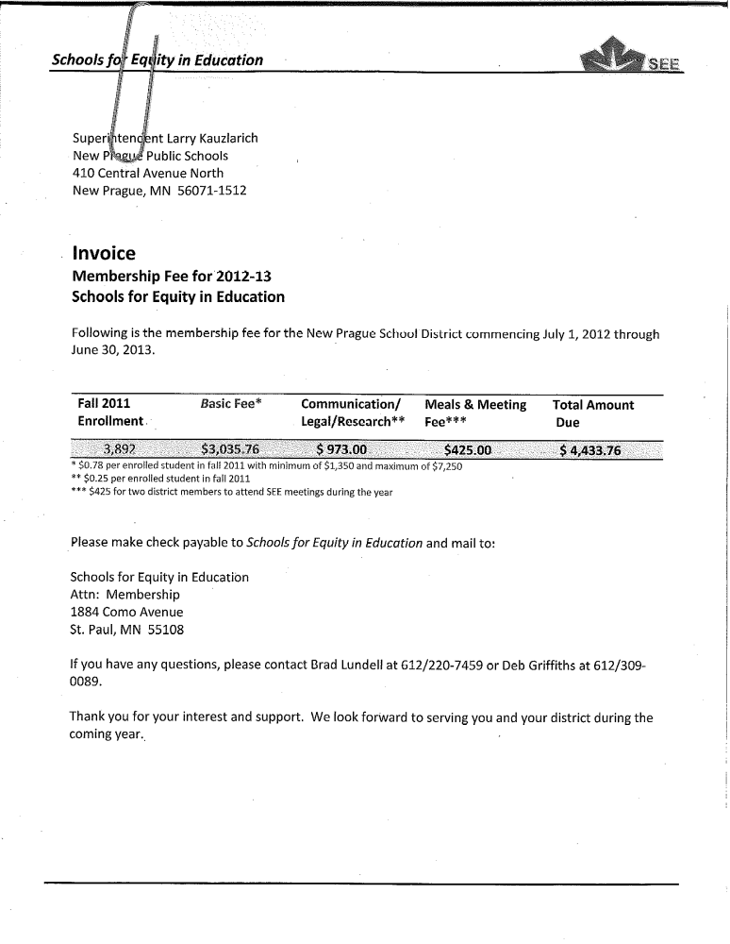

- Approval of 2012/2013 Budget: Supt Comments: Sandy will present the final 2012-13 budget for your approval.

- Approve the FY 12-13 Health & Safety budget.
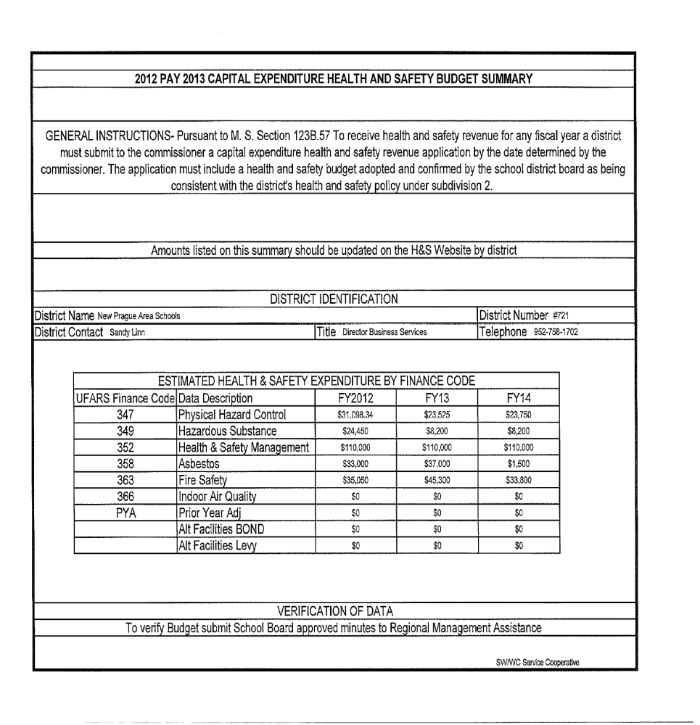

Approve Resolution for Transfer of Funds: Supt. Comment:
New Prague Area Schools School Board
Resolution to make a permanent fund transfer from Fund 01 to Fund 04
WHEREAS, Minnesota Statute 121A.19 allows an independent school district to permanently transfer funds from the general fund to the community services fund for the purpose of covering unreimbursed early childhood screening expenditures,
WHEREAS, Minnesota state aid has been insufficient for developmental screening expenditures and this has contributed to a large unassigned fund balance in Fund 04,
NOW, THEREFORE, BE IT RESOLVED by the New Prague Area School Board of Education, that New Prague Area Schools will transfer $25,000 of its unassigned general fund balance to the unassigned community services fund in FY 11-12.
Member _____________________ moved the resolution.
The motion was duly seconded by Board member ________________________.
WHEREUPON, a vote was taken upon the foregoing Resolution and the following Board members voted in favor: ___________________________________________________Absent: __________________.
Board members voted against the same: ___________________________.

- Approve Resolution to Commit Funds

New Prague Area Schools School Board
Resolution to Commit Funds for Future Severance and Other Post Employment Benefit Payments

WHEREAS, the current master agreements with teachers and support staff include a severance or other post employment benefit provision that represents a significant future liability to the school district.
WHEREAS, GASB 54 reporting guidelines allow, by board resolution, a school district to commit unassigned general fund balance to account for future severance and other post employment benefit liability.
NOW, THEREFORE, BE IT RESOLVED by the New Prague Area School Board of Education, that New Prague Area Schools will commit a portion of the unassigned general fund balance to account for future severance and other post employment benefit liability to enable better planning for future payments. As it desires, the school board can adjust the amount of money committed for these purposes within the general fund balance.
The Board of Education committed $871,013 in the general fund for FY 10-11.
New Prague Area Schools paid $144,771 in severance payments during FY 11-12.
The Board of Education commits an additional $200,000 in the general fund for FY 11-12.
The total amount of general fund committed at the end of FY 11-12 is $926,242.

Member _____________________ moved the resolution.
The motion was duly seconded by Board member ________________________.
WHEREUPON, a vote was taken upon the foregoing Resolution and the following Board members voted in favor: ___________________________________________________Absent: __________________.
Board members voted against the same: ___________________________.
WHEREUPON the Resolution was declared passed and adopted.
Approved: June 25, 2012

